I HEREBY GIVE YOU NOTICE

THAT A MEETING OF THE MESSING CUM INWORTH PARISH COUNCIL WILL BE HELD ON Thursday 19th January at 7.30pm
in Messing Village Hall.

MEMBERS OF THE PRESS AND PUBLIC ARE WELCOME

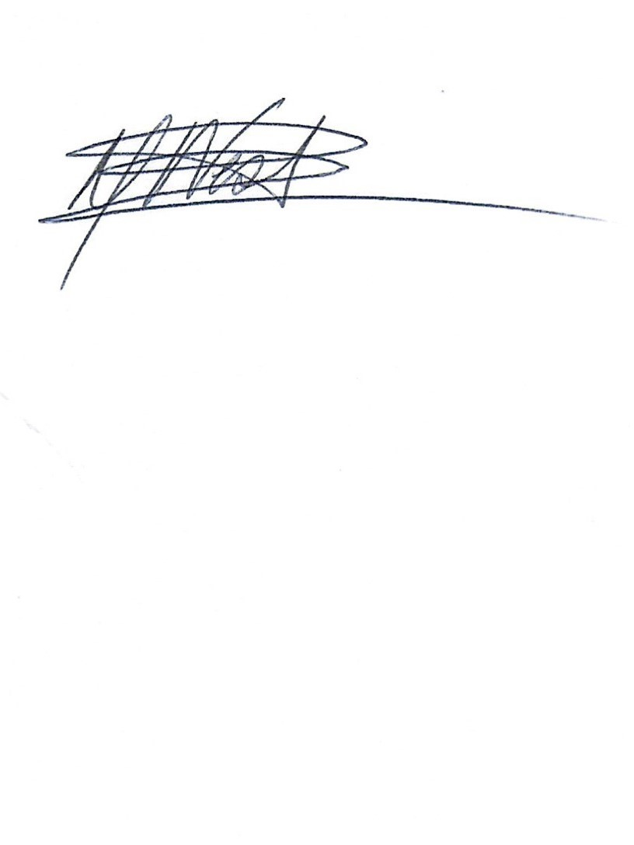
Signed:

Linda Berrett-West - Clerk to the Council
13th January 2023

AGENDA

AGENDA
AGENDA
23/001 | To consider and accept the apologies for absence (LGA 1972 s85 (1)
23/002 | Declaration of Interest  Members to declare any interests, including Disclosable Pecuniary Interests they may have in agenda items that accord with the requirements of the Town Council’s Code of Conduct and to consider any prior requests from members for Dispensations that accord with Localism Act 2011 s33(b-e) (NB this does not preclude any later declarations)
23/003 | To approve the minutes of the Full Council meeting held on 15th December 22 (LGA 1972, s12, para 41)
23/004 | To hear from members of the public (max 15 minutes /3 minutes per person)
23/005 | To receive County Councillor and Borough Councillors Reports
 | 005.1 County Councillor Kevin Bentley
 | 005.2 Borough Councillors Andrew Ellis & Jackie McLean
23/006 | Clerks Report  006.1 Statement made regarding former Parish Councillor - 12th January 2023  006.2 Allotment update
23/007 | Finance
 | 007.1 |  | Statement of Accounts from RFO  Budget preparation for February full council meeting
 | 007.2 |  | Receipts for month December 2022  Interest of Premium Business Account  Returned cheque 200068 (K Palmer)  Orchard Credit / Tiptree Show  Orchard Credit / Santa in the Orchard Event |  |  | 6.84  1674.58  67.70  296.00
 |  |  | Total |  |  | £ 2045.12
 | 007.3 |  | Expenditure for month December 2022  DD – EE Mobile Phone  200068 – K Palmer Locum Fees |  |  | 5.46  1674.58
 |  |  | Total |  |  | £ 1680.04
 | 007.4 |  | Payment for Approval January 2023  2000** - J Etheridge refund  2000** - Reissued cheque K Palmer Locum Fees  2000** - Parish Clerk Salary & Allowances (Aug to Dec 22) |  |  | 19.00  1674.58  TBC
 |  |  | Total |  |  | £ 1693.58
23/008 | Planning Matters & Applications
 | 008.1 | Planning Matters
 | 221005 | Osborne House – CBC Decision
 | 008.2 |  | New Planning Applications Received
 | No new applications received
 | 008.3 |  | Planning Applications Previously Reviewed
 | 222960 |  | 3 Bouchiers Place,  Kelvedon Road, |  | First storey rear extension, installation of sliding doors, infill of front covered porch and addition of velux windows. | PC approved
 | 220264 |  | Bouchiers Hall,  Road, CO5 9TW |  | Tree 1 Oak. Work to be undertaken is reduce back to last pollard points. Trees two and Three Firs - 7 Metre height reduction. Tree four Hazel - to be felled. Trees Five to Nine are leylandi to have a 6-metre crown reduction. | PC approved
 | 221043 |  | Park Farm, Kelvedon Road, CO5 9SH |  | Electricity Act 1989- overhead lines (exemption) Regulations 2009 | PC approved
 | 008.4 |  | Decisions Issued by CBC
 | 221438 |  | Bouchiers Hall,  Road,CO5 9TW |  | Single storey/storey and a half linked rear extension to Grade II listed building | CBC Approved
 | 221439 |  | Bouchiers Hall,  Road, CO5 9TW |  | Single storey/storey and a half linked  rear extension to Grade II listed building
23/009 | Policies & Procedures
 | 009.1 |  | Terms of Reference for McIPC A12 Working Party – Review & adopt
 | 009.2 |  | Terms of Reference for McIPC A12 Committee – Review & adopt
23/010 | A12 / A120 Widening
 | 010.1 |  | To hear reports on Planning Inspectorate hearings on 12th January 2022
 | 010.2 |  | Review communication with National Highways
 | 010.3 |  | To hear reports from Messing Inworth Action Group
 | 010.4 |  | To receive and consider any requests for funds towards professional fee’s
23/011 | Essex Highways
 | 011.1 |  | Review for updates
23/012 | Precept 2023-24
 | 012.1 | To review schedule circulated prior to meeting by the Clerk and to adopt the precept for year 2023-24
23/013 | Orchard
 | 013.1  013.2 |  |  | To hear report on the Santa in the Orchard event held on 4th December  Orchard Accounts
23/014 | 20’s Plenty
 | 014.1 |  |  | Review progress and discuss next stages
23/015 | Coronation Events
 | 015.1 |  |  | Discuss ideas for celebrating HR King Charles III coronation on 6th May 2023
23/016 | Parish Maintenance
 | 016.1 |  | Update/quote for repair to Bus Shelter Roof
 | 016.2  016.3  016.4  016.5 |  | Update/quote for repair to damage to porthole on play equipment  Repair to Lodge Road  Flooding Messing Hall  Road sign – Messing
23/017 | Village Requests
 | 017.1  017.2 |  | Review for update of bench for play area – K Jackson  Review for update on plaque – J Dey
23/018 | Information Exchange & Items for the next agenda (No votes or decisions can be taken)
23/019 | To confirm date & time of next meeting  Thursday 16th February 2023 at 7.30pm

