I HEREBY GIVE YOU NOTICE

THAT A MEETING OF THE MESSING CUM INWORTH PARISH COUNCIL WILL BE HELD ON

TUESDAY 18th October 2022 at 7.30pm in Messing Village Hall.

MEMBERS OF THE PRESS AND PUBLIC ARE WELCOME
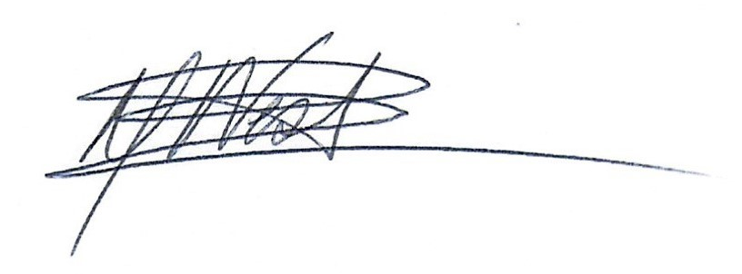
Signed:

Linda Berrett-West - Clerk to the Council
13th October 2022

AGENDA
1 | 086/22 | To consider and accept the apologies for absence (LGA 1972 s85 (1)
2 | 087/22 | To receive the Declarations of Interest  Members to declare any interests, including Disclosable Pecuniary Interests they may have in agenda items that accord with the requirements of the Town Council’s Code of Conduct and to consider any prior requests from members for Dispensations that accord with Localism Act 2011 s33(b-e) (NB this does not preclude any later declarations)
3 | 088/22 | To approve the minutes of the Full Council meeting held on 4th October 2022  LGA 1972, sch 12, para 41
4 | 089/22 | To hear from members of the public (max 15 minutes/3 minutes per person)
5 | 090/22 | To discuss outcome in relation to the section 16 statement (submission deadline 11th October 2022) following meeting between Cllr Andrew Harding and Cllr Johnathon Greenwood from Tiptree Parish Council
6 | 091/22 | A12/A120 widening:  - Update on National Highways communications.  - To hear any reports from Community Action Groups.  - To consider any request for funds towards professional fees
7 | 092/22 | To review allotments and future management.
8 | 093/22 | To review & discuss the transport plan for the construction phase of the Solar Farm in Layer de la Haye. Transport Plan circulated with agenda
9 | 094/22 | To agree the closing of the Book of Condolence & communicating its storage location with The Private Secretary to His Majesty The King within the Parish Councils archives. Letter circulated with agenda
10 | 095/22 | To agree location for a commemorative bench to be sited in play area & review wording for plaque. Clerk consulting with Wicksteed re proposed location(s) to ensure no implications to sited play equipment.
11 | 096/22 | To review the Orchard in relation to annual accounts, future funding for items such as signs, plaques, benches, picnic table. To discuss ways to increase use of room available on site.
12 | 097/22 | To review grounds maintenance schedule in preparation for going out to tender. This should be shown by area & required tasks within,
13 | 098/22 | To review planning applications  222067 – change of use: agricultural to dog walking field – CBC Refused
14 | 099/22 | To consider and approve the payments and expenses schedule as presented
15 | 100/22 | Information for the next meeting – no decisions will be made. Verbal.
16 | 101/22 | Date of Next Meeting:  Thursday 17th November 2022, Full Council, 7.30pm in Messing Village Hall

