I HEREBY GIVE YOU NOTICE

THAT A MEETING OF THE MESSING CUM INWORTH PARISH COUNCIL WILL BE HELD ON Thursday 13th April 2023 at 7.30pm
in Messing Village Hall.

MEMBERS OF THE PRESS AND PUBLIC ARE WELCOME

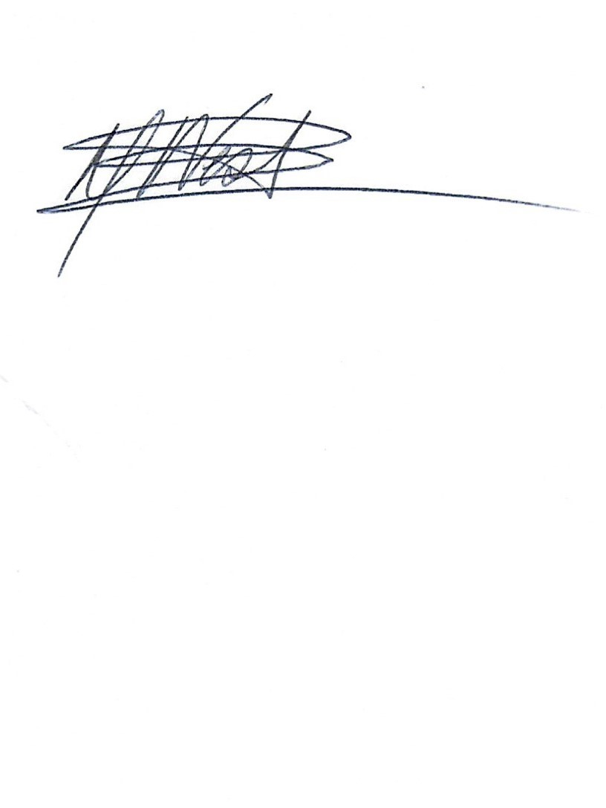
Signed:

Linda Berrett-West - Clerk to the Council
6th April 2023

AGENDA
23/063 | To consider and accept the apologies for absence (LGA 1972 s85 (1)
23/064 | Declaration of Interest  Members to declare any interests, including Disclosable Pecuniary Interests they may have in agenda items that accord with the requirements of the Town Council’s Code of Conduct and to consider any prior requests from members for Dispensations that accord with Localism Act 2011 s33(b-e) (NB this does not preclude any later declarations)
23/065 | To approve the minutes of the Full Council meeting held on 16th March 23 (LGA 1972, s12, para 41)
23/066 | To hear from members of the public (max 15 minutes /3 minutes per person)
23/067 | To receive County Councillor and Borough Councillors Reports
 | 067.1 County Councillor Kevin Bentley
 | 067.2 Borough Councillors Andrew Ellis & Jackie McLean
23/068 | Clerks Report  068.1 Allotment update
23/069 | Finance
 | 069.1 | Statement of Accounts from RFO  Recommendation to accept previously prepared budget & reserves for 23-24, See item 23/074s  Re-issue cheque for Locum work (2nd rejection by Unity Bank)
 | 069.2 | Receipts for month March 2023  Plot 1 – 6 months rent  Returned cheque 200051  Business Account Interest | 20.50  1674.58  15.23
 |  | Total | £1710.31
 | 069.3 | Expenditure for month March 2023  DD – EE Mobile Phone | 5.46
 |  | Total | £ 5.46
 | 069.4 | Payments for Approval April 2023  200075 – Clerk Salary (17th Aug 22 to 31st March 23)  200076 – 3 Keys cut for noticeboard  200077 – Locum Fee’s payable to K Palmer | TBA  24.00  1674.58
 |  | Total | £1698.58
23/070 | Planning Matters & Applications
 | 070.1 | Planning Matters
 |  | Nothing to report
 | 070.2 | New Planning Applications Received  No new applications received
 | 070.3 | Planning Applications Previously Reviewed
 |  | Nothing to Report
 | 070.4 | Decisions Issued by CBC
 |  | Nothing to report
23/071 | Policies & Procedures
 | 071.1 Update on advice sought from EALC
23/072 | A12 / A120 Widening
 | 072.1 | To review for updates
 | 072.2 | To hear reports from Messing Inworth Action Group
23/073 | Essex Highways
 | 073.1 | Review for updates
23/074 | Budget 2023-24
 | 074.1 | To consider & approve budget & reserves for 23/24. Detail circulated to all Councillors prior to February meeting
23/075 | S106 Report
 | 075.1  075.2  075.3 | Community update  Recreational update  Possible funds for orchard
23/076 | Parish Wish List
 | 076.1 | Review current list & update
23/077 | Annual Parish Meeting (APM) & Annual Parish Council Meeting (APCM)
 | 077.1  077.2  077.3 | Date moved to Tuesday 23rd May due to holiday commitments  Chairperson & Vice- Chairperson roles  Confirm attendance of Councillors
23/078 | Allotments
 | 078.1  078.2 | Discuss how to advertise facility & Waiting list  Discuss current use by Plot Holders
23/079 | 20’s Plenty
 | 079.1 | Review & approve letter requesting CCllr Kevin Bentley support
23/080 | Coronation Events
 | 080.1 | Review planned event to be held on Sunday 7th May to celebrate HR King Charles III coronation.
23/081 | Parish Maintenance
 | 081.1 | Review quotes for repair to Bus Shelter Roof
 | 081.2  081.3  081.4  081.5 | Review quotes for repair to damage to porthole on play equipment  Road sign on Lodge Road reported to Highways ref 376417  Flooding outside of Messing village Hall reported to ECC Highways ref 2823718 & Email to Cllr Kevin Bentley following Highway Reponse  Illegal road markings
23/082 | Village Requests
 | 082.1  082.2 | Update on planting of 2 new trees on the village green ref M Tonge request  Review for update of bench for play area – K Jackson
23/083 | Information Exchange & Items for the next agenda (No votes or decisions can be taken)
23/084 | To confirm date & time of next meeting  Tuesday 23rd May 2023 at 7.00pm – Annual Parish Meeting  Tuesday 23rd May 2023 at 7.30pm – Annual Parish Council Meeting

